The trip sold out in just seven minutes – and was restricted to just eighteen lucky travellers. I had been basking in my good luck for almost ten months, from having my booking confirmed on 14th January to finally boarding the plane on 2nd November – I was on my way to follow in Orwell’s footsteps in Morocco!
This was to be my first trip with the Orwell Society – though I hope not my last – and I was immediately welcomed into the group, who came from all over the world – from San Francisco and New Jersey, Germany, Australia, and the UK – brought together by a shared love and admiration for the works of Orwell, and desire to know more about his experience in Morocco.
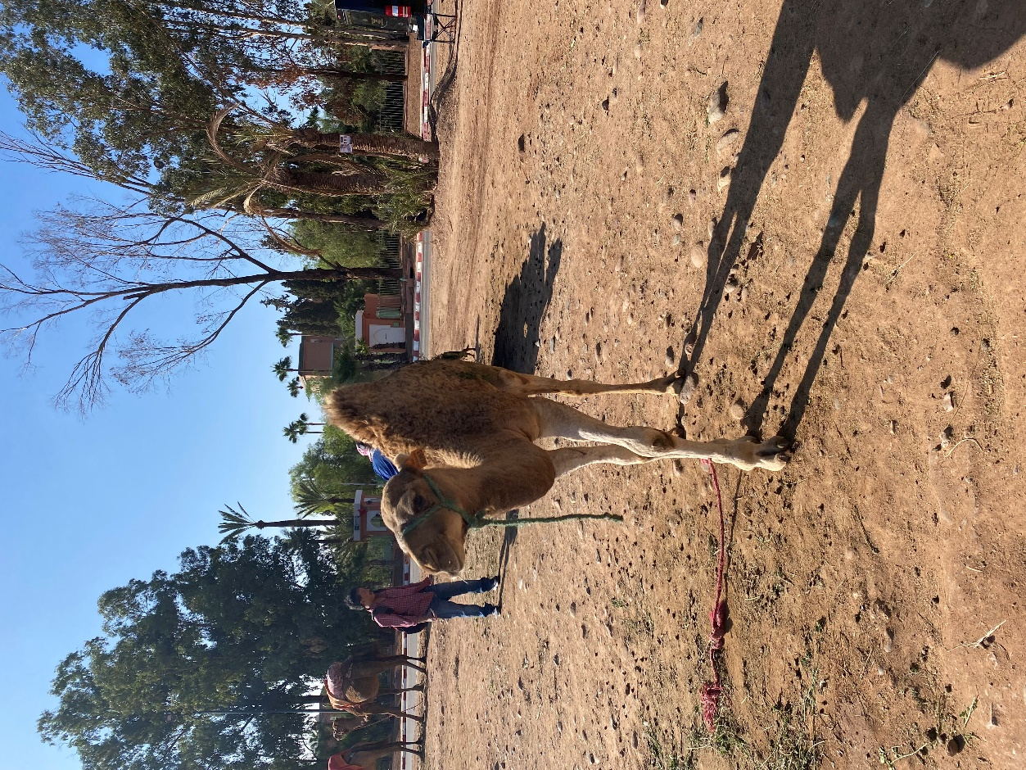
A friendly camel by the Oued Tensift
Quentin and Liz Kopp ensured the trip ran like a well-oiled machine – we were all very well looked after, and a great amount of care had clearly gone into this, though on the surface it seemed effortless. We were guided by the meticulous research of Kevin Carter (we hope at least one book on Orwell’s time in Morocco will follow soon!) and what was truly special was having Richard Blair, Orwell’s son, there with us, reading from Kevin’s carefully selected extracts of Orwell and Eileen’s writings at each site. This head and heart connection to the places we visited – the detailed research, the facts and artefacts, alongside the gift of this direct connection to the man himself – was an amazing thing to experience.
Our journeys to Marrakech, even those who had travelled from the US, were nothing compared to Eric and Eileen’s, the complexities of which were explained to us by Kevin when we visited the Marrakech train station. This was where the couple eventually arrived, having travelled by boat from Tilbury Dock, via Gibraltar (by mistake – they could have got off at Tangier, where the ship docked first) then back to Tangier, where they hoped to get a ship to Casablanca, but the boats were full, so they had to travel by train, through Spanish Morocco – which Orwell had been hoping to avoid, as his passport showed that he had fought on the Republican side in Spain. However, they passed through without incident (other than their newspapers being confiscated) crossing two borders before reaching Pierrejean (now Sidi Kacem) in French Morocco, where they lost their baggage. They then took a connecting train to Casablanca, staying for two nights, waiting to be reunited with their suitcases, before taking the train to Marrakech. My flight from Gatwick was slightly delayed due to Storm Ciaran and had to be rerouted to due to French Air Traffic Control strikes – but it doesn’t quite compete!
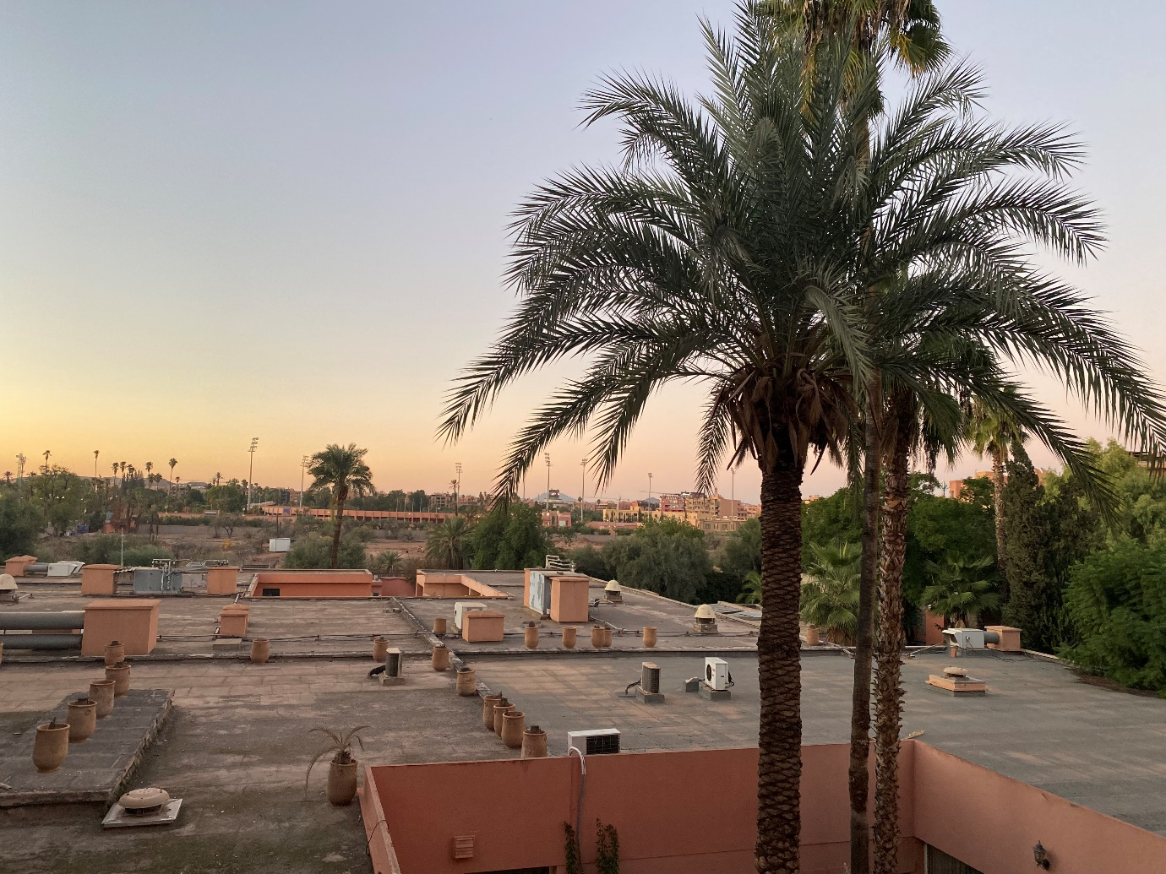
View from my hotel room
Quentin and Kevin met us at the airport, along with our brilliant driver, Ismail, who went above and beyond throughout the week, including driving three hours back to Casablanca at 3am to replace our dodgy-sounding minibus! The hotel President Kennedy Resort was very welcoming, with a lovely (if unexpectedly cold!) swimming pool – several of our party also tried the hammam, which was highly recommended. We ate at the hotel the first night, after some Casablanca beers and a dip in the pool, ready for the busy week ahead.
Our first stop was the Oued Tensift. We stood on the banks of the very dry river – it flooded when Orwell was there – and heard Richard read from his father’s diary of the ‘fresh water mussels, very similar to those in the Thames, moving to & fro in the mud leaving deep track behind them’ – no chance of spotting them on our visit, the dry river instead occupied by a stray dog! We looked at photographs taken by Orwell in the area, provided by Kevin – in one, you could even see Orwell’s shadow. The scene was instantly recognisable – aside from the addition of cars, little in the scenery seemed to have changed.
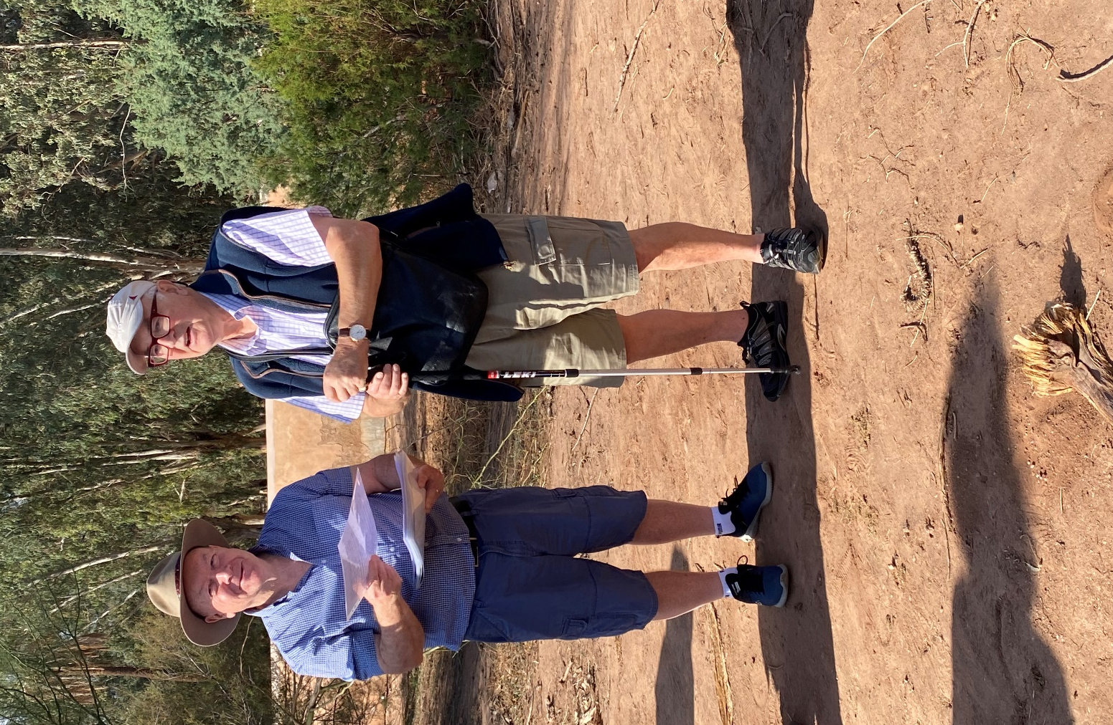
Richard and Kevin, reading from Orwell’s diaries at the Oued Tensift.
Next, fittingly, we moved to the Water Museum, which was beautifully put together and told a very expansive and detailed history of water in the region, its political, social, cultural, and environmental importance, risks and customs – especially how water is shared in communities, by the Jemaa, who regulate the management of natural resources to avoid conflicts related to water use or rights.
Next, we visited the approximate location of Villa Simont, where Orwell and Eileen stayed in Marrakech, expertly calculated by Kevin, working by the distances Orwell notes in his diaries. Although just an empty site of rubble and rubbish now – and a few stray dogs - it was wonderful to hear Richard read on the spot where the villa might have stood, and to see the photos of how it had been, including the observatory where Orwell wrote ‘Coming Up For Air.’
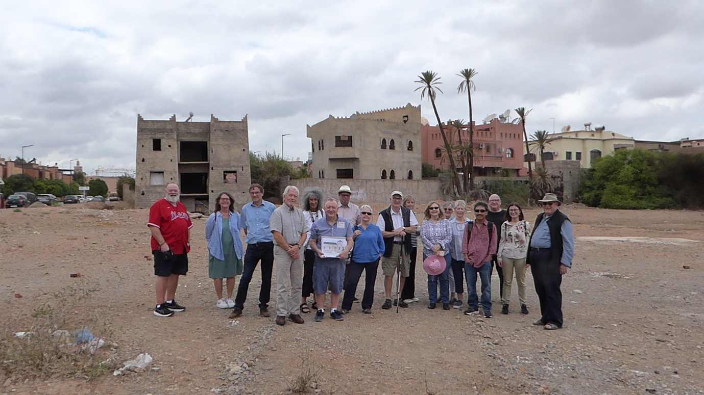
Group at the approximate site of the Villa Simont
After lunch at the brilliantly named Hotel Wazo (there was a little ‘oiseau’ chirping from his cage inside!), it was back to our hotel, before heading out to the Jemma El Fna (main square) for dinner at Cafe France - excellent tagine, overlooking the bustling square. We returned to the Jemma El Fna in the morning for an Orwell pilgrimage – to the former hotel where Orwell and Eileen first stayed (Eileen noticed it was a brothel – Orwell didn’t!), and the former home of Madame Vellat, which they then moved to (before moving on to Villa Simont).
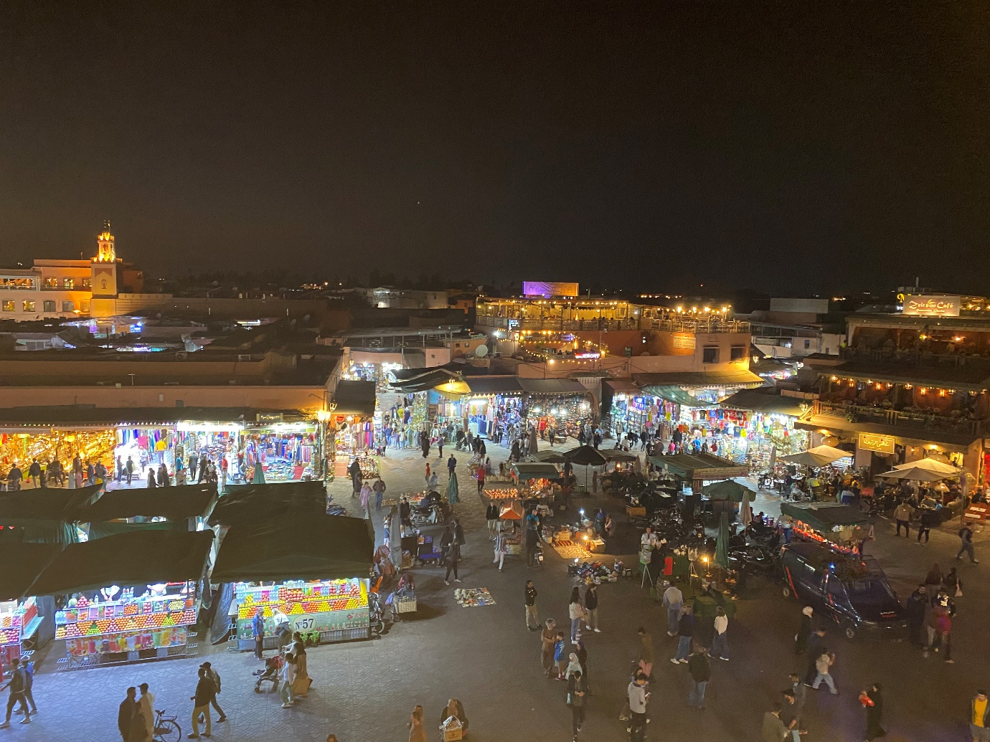
Jemma El Fna by night
We walked through the medina to the Mellah, the Jewish quarter, stopping for mint tea and excellent lunch. We then stopped at the site of the former British Consulate where Eric and Eileen registered upon arrival (with Orwell’s date of birth incorrectly marked as 1902 rather than 1903 – apparently a mistake also on his passport!); the hospital where Orwell was seen by Dr Diot, a friend of a friend of Eileen’s brother Lawrence; and the Hotel de Ville where the couple also registered - with some interesting spellings of Eileen’s home town of South Shields (South Swecas!), and her maiden name.
The next day we made the rainy journey to Casablanca, to the beautiful replica of Rick’s Café – amazing food and setting to live out my Ingrid Bergman dreams! We drove past the railway station (rain still heavy) where Eric and Eileen arrived, then on to the Rialto cinema, where they watched a film on their brief stay, and finally the city hall, police station and the French Consulate-General. The statue of the first Resident-General, Marshal Lyautey, was moved to the grounds of the French Consulate in April 1959 (Morocco gained independence in 1956) from its former position in the middle of the main square in front of the city’s courthouse.
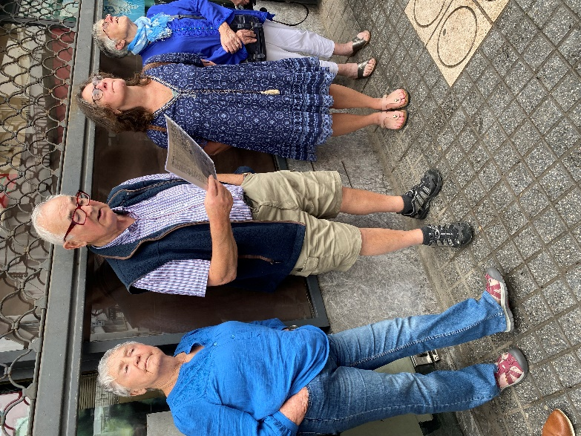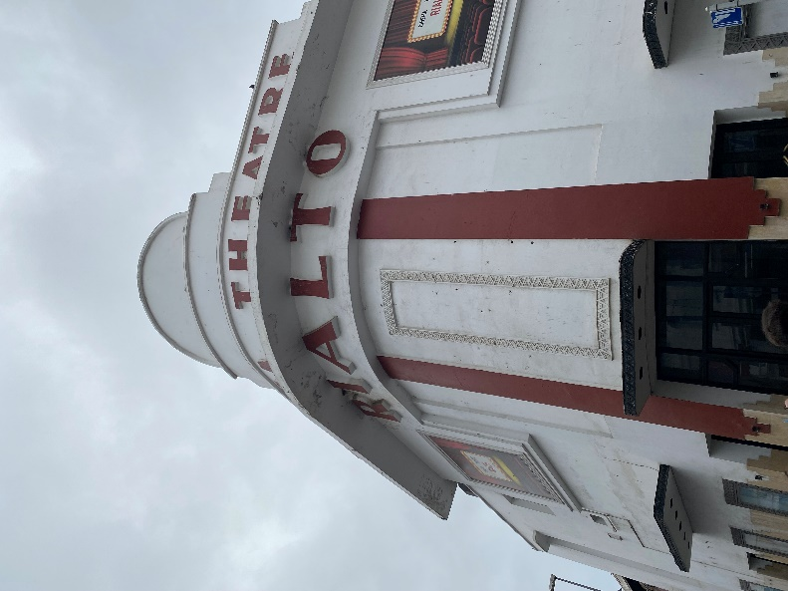
The Rialto cinema, Richard reading
On the drive back, rain continued most of the way, but stopped about an hour from Marrakech. Sunsets are very swift and orange there (Orwell mentions a ‘green’ sky at sunset in his diaries – I tried to see what he meant but it was far more orange, pink and mauve to me!) and the bus journey gave the perfect opportunity to appreciate this.
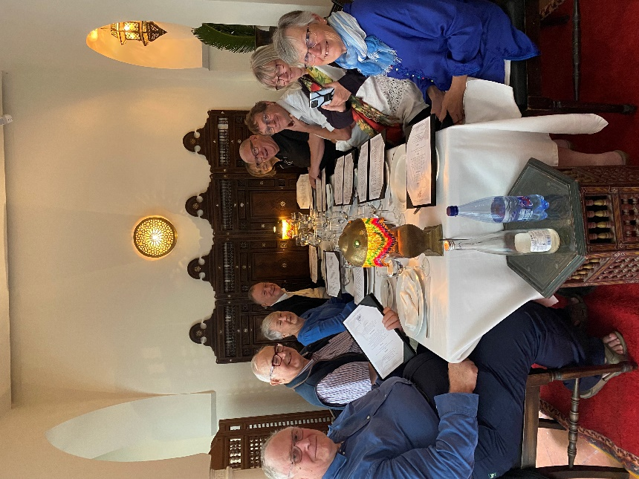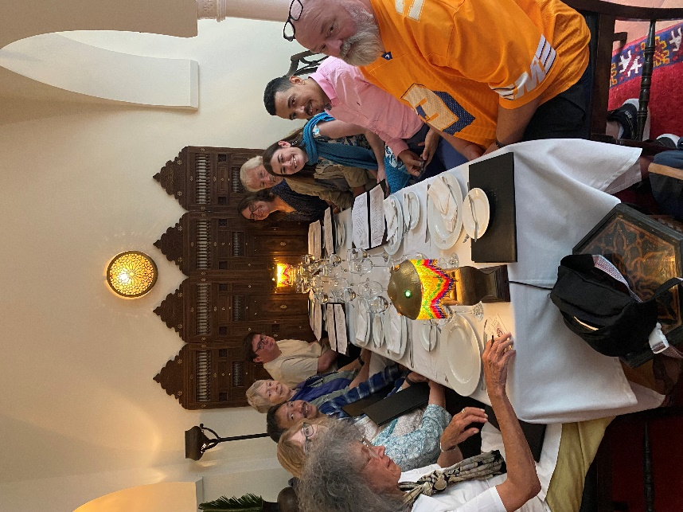
The group at Rick’s Cafe
Throughout, the food was wonderful – during our stay, we visited both branches (‘mother’ and ‘daughter’ establishments) of Al Fassia, a brilliant community enterprise where all the workers are women who have escaped from abusive relationships or difficult home situations. A slight miscommunication in the ordering did mean we ended up having two main courses (plus starters and desserts!) – hard to complain about double tagine, when the flavours are so delicious!
The next day, we visited the Jnane El Harti gardens, mentioned in Orwell’s Marrakech essay as the site of the gazelle with the hindquarters that looked good enough to eat with mint sauce! The gardens used to contain a zoo. They are also where Orwell saw the turtles ‘coming up for air’..
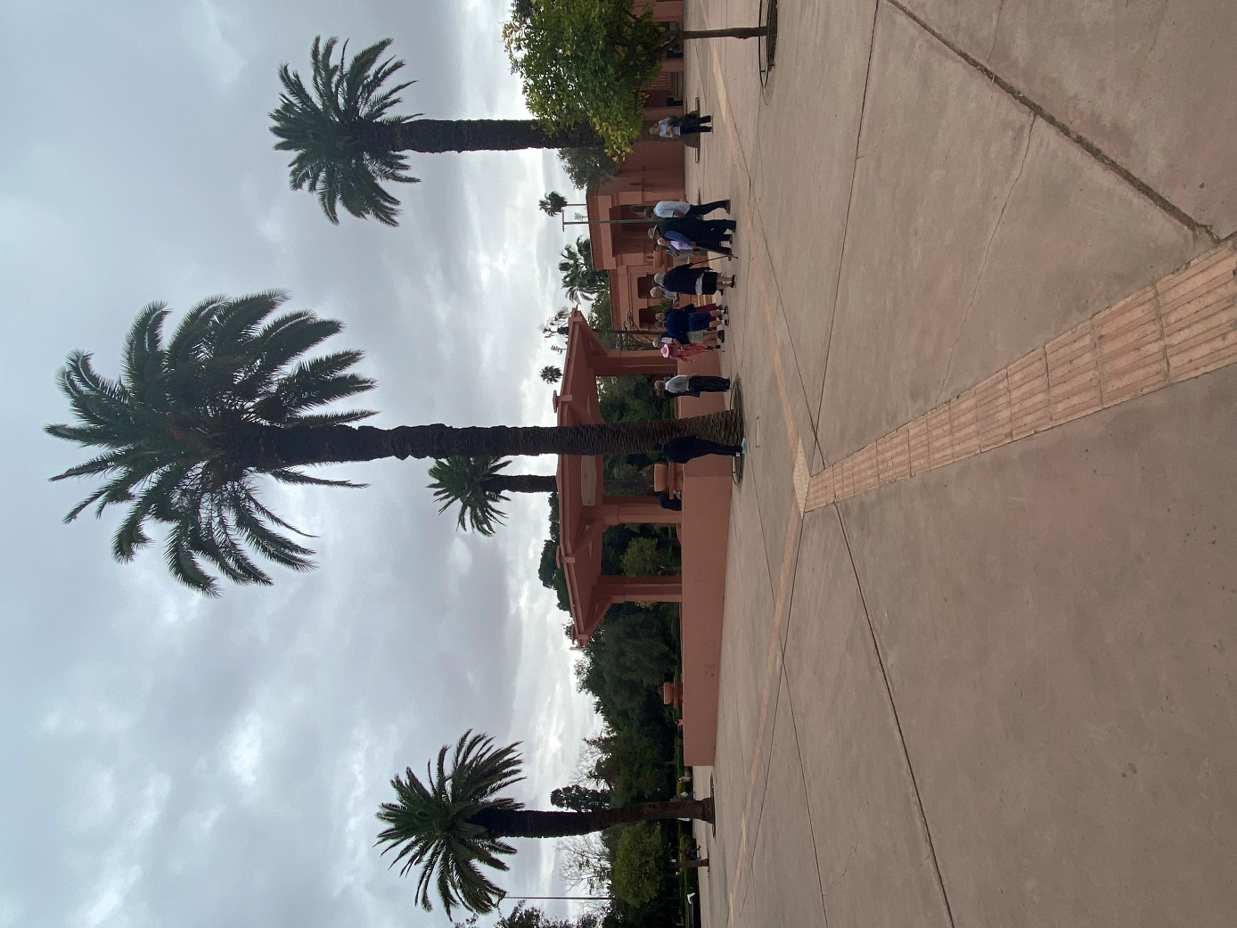
Jnane el Harti gardens
Next, to the hospital which Eileen visited for neuralgia and then to the Cafe Les Negociants, frequented by Eileen and Eric. We stopped for café au lait and more wonders from Kevin’s stash of photographs, documents and stories – we were even able to peruse the Blairs’ shopping lists!
We visited Chatr bookshop, also frequented by Orwell and Eileen, to stock up on postcards, and lunched at Chez Lamine - which may not have been visited by Orwell but was by Gordon Ramsey, Jamie Oliver and Mary Berry! In the afternoon, we went to the European cemetery, where Simon Fankhauser (owner of the Villa Simont) and Madame Vellat are buried - Madame Vellat rather sadly in an unmarked grave. But there was life in the cemetery – Ismail handed me a ‘gift’, a small, flailing tortoise with a long stalk of grass in his mouth, who seemed fairly unfazed (his head stayed out) but peed pretty spectacularly!
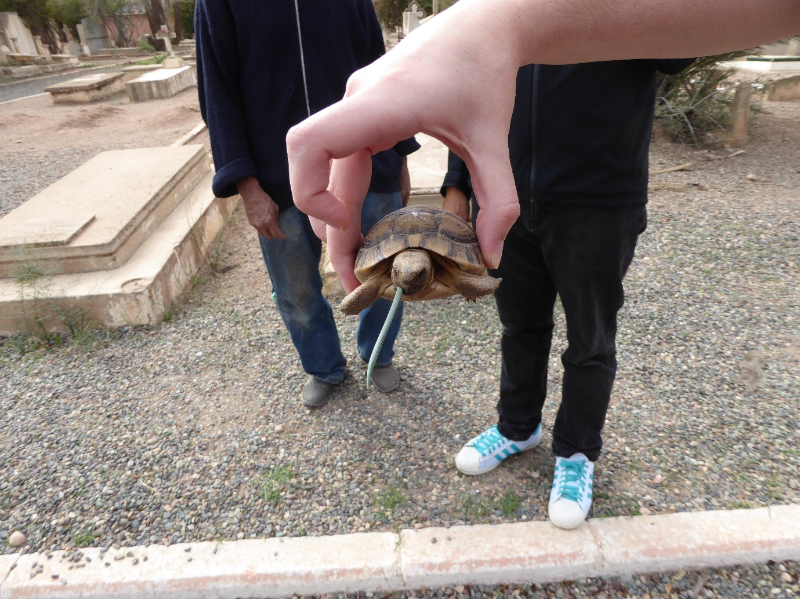
Our final day together was possibly the highlight of my trip – up to the High Atlas mountains. We stopped at Taddert (many places were called Taddert, or similar, as it means village – so props again to Kevin and Quentin for tracking down the right one!) and visited the Auberge des Noyers, the hotel where Orwell and Eileen stayed in Jan 1939 after Orwell had completed his first draft of Coming Up for Air. We enjoyed views ‘panoramique’, some interested cats, strong mint tea, walnuts from the walnut tree, and tomato omelettes with excellent bread, before a chance to explore the hotel - now decaying and worn but with remnants of its former grandeur, especially the bar downstairs where Eric and Eileen likely spent their evenings by the open fire. Then on, to the highest point of the mountains - it’s not clear the Blairs ever made it here, but the views were spectacular. Very cold. Dramatic drive back down again and back to the hotel to swim/relax before our final dinner at the ‘mother’ Al Fassia – with two tagines once again!
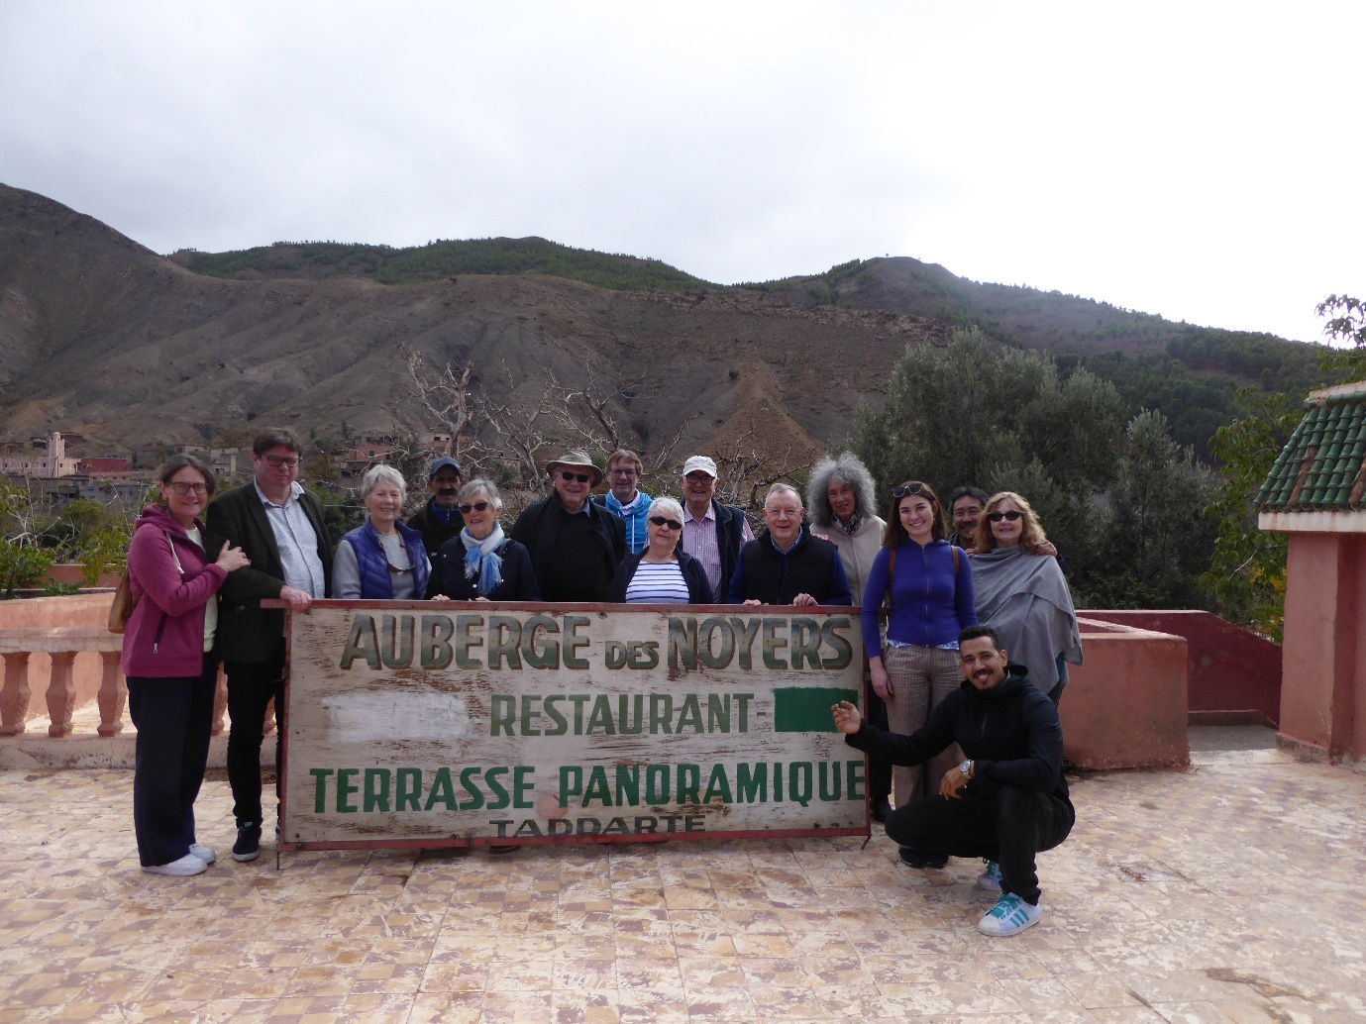
I would happily have spent another week or more in Marrakech. It was an incredible opportunity and an extremely well organised trip. It’s one thing to hear or to read about Orwell’s time in Marrakech, but quite another to stand in the places he stood, to hear his words read by his son, and to be given insights into Orwell and Eileen’s time here from such rich research and understanding. A massive thank you to Quentin, Kevin, Richard and Liz – I’m told the Society will be returning next year, so do whatever you need to do to snap up one of those spaces – they may be gone in even less than seven minutes next time!

